**Ideation Phase**

**Brainstorm & Idea Prioritization Template**

|  |  |
| --- | --- |
| Date | 25 June 2025 |
| Team ID | LTVIP2025TMID59421 |
| Project Name | OrderOnTheGo: Your On-Demand Food Ordering Solution |
| Maximum Marks | 4 Marks |

**Brainstorm & Idea Prioritization Template:**

**Brainstorming** creates a supportive and open environment where every team member is encouraged to contribute ideas freely. The focus is on quantity over perfection, welcoming bold, unconventional thinking. Participants build on each other’s input to spark creativity and generate a wide range of innovative solutions.

Use this template in your brainstorming sessions to help your team tap into their imagination and shape ideas collaboratively—even when working remotely.

**Step-1: Team Gathering, Collaboration and Select the Problem Statement**

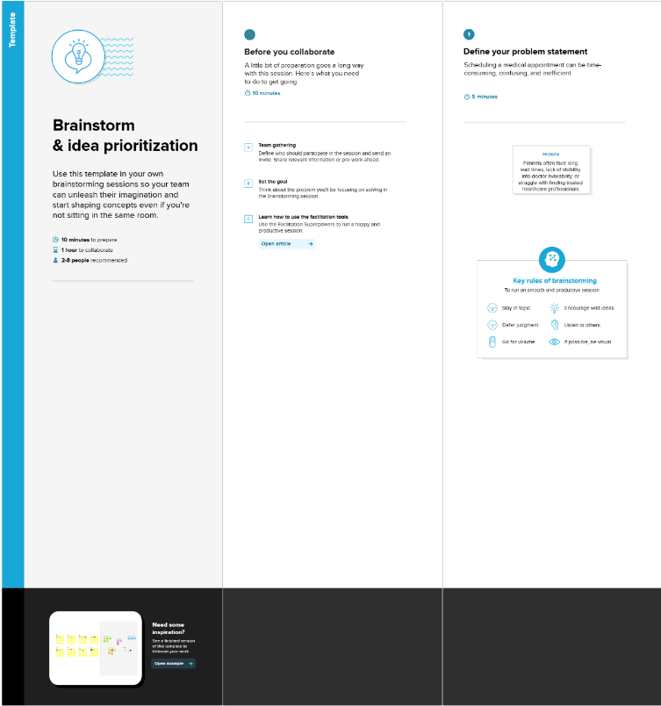

**Step-2: Brainstorm, Idea Listing and Grouping**

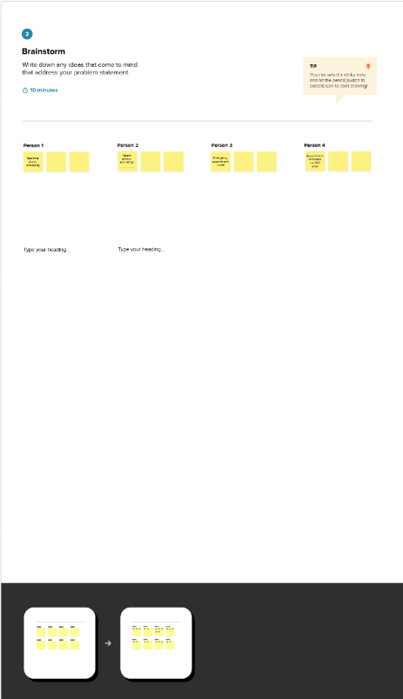

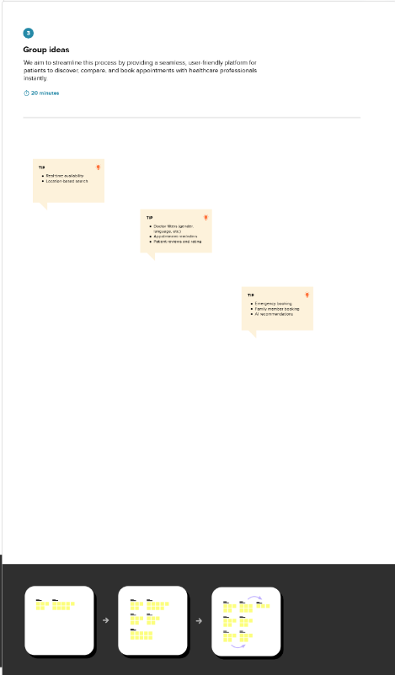

**Step-3: Idea Prioritization**

